**Project Design Phase-II**

**Technology Stack (Architecture & Stack)**

|  |  |
| --- | --- |
| **Date** | **04th November 2023** |
| **Team ID** | **Team - 591979** |
| **Project Name** | **ASL - Alphabet Image Recognition** |
| **Maximum Marks** | **4 Marks** |
| **Team members** | **Pujyam Sathvika, Rishika Krishna Ch** |

**Technical Architecture:**

The technical architecture shows the user interface, the integration, and the back end and how they are tied together to make the project.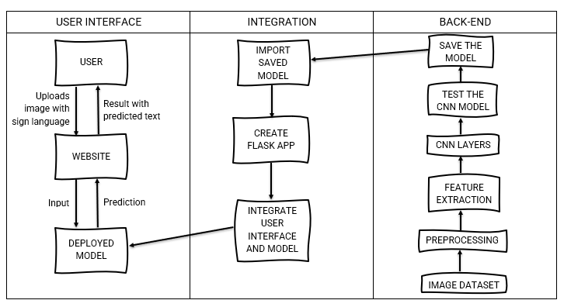

**Table-1 : Components & Technologies:**

|  |  |  |  |
| --- | --- | --- | --- |
| **S.No** | **Component** | **Description** | **Technology** |
| 1. | Front - End | Web interface for user access | HTML, CSS, JavaScript |
| 2. | Back - End | Data processing | Python |
| 3. | ASL recognition | An ML model for ASL sign recognition | (CNN) Convolution Neural Network |
| 4. | User Registration | Enable user registration | Database |
| 5. | Sign Language Database | Database storage for ASL signs | SQL Database |
| 6. | Framework | To create website and integrate it with CNN model | Flask with python |

**Table-2: Application Characteristics:**

|  |  |  |  |
| --- | --- | --- | --- |
| **S.No** | **Characteristics** | **Description** | **Technology** |
| 1. | Open source Frameworks | The open source frameworks used | Flask |
| 2. | Availability | Ensures the application is available | Python, Flask |
| 3. | Security | Ensures the application is secure | Flask, Python |